In **Microsoft Word**, an **illustration** refers to any visual element added to a document to enhance its content or improve its presentation. These illustrations help make documents more engaging, visually appealing, and informative.

**Common Types of Illustrations in MS Word:**

1. **Pictures**:
   * Images from your computer or online.
   * Inserted via **Insert > Pictures**.
2. **Shapes**:
   * Geometric or custom figures like arrows, lines, and stars.
   * Found under **Insert > Shapes**.
3. **SmartArt**:
   * Pre-designed graphics for processes, hierarchies, and relationships.
   * Accessed via **Insert > SmartArt**.
4. **Charts**:
   * Graphical representations of data (e.g., pie charts, bar graphs).
   * Added using **Insert > Chart**.
5. **Icons**:
   * Small, ready-made graphics to symbolize ideas or concepts.
   * Available under **Insert > Icons**.
6. **3D Models**:
   * Interactive 3D graphics to visualize objects from multiple angles.
   * Found under **Insert > 3D Models**.
7. **Screenshots**:
   * Snapshots of open applications or windows on your computer.
   * Added via **Insert > Screenshot**.

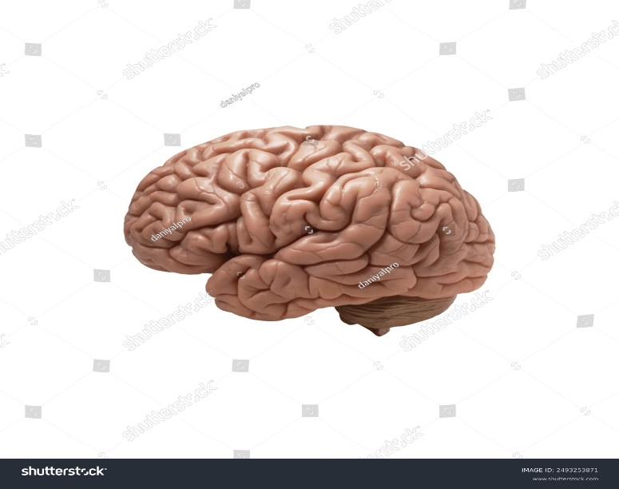



Screenshot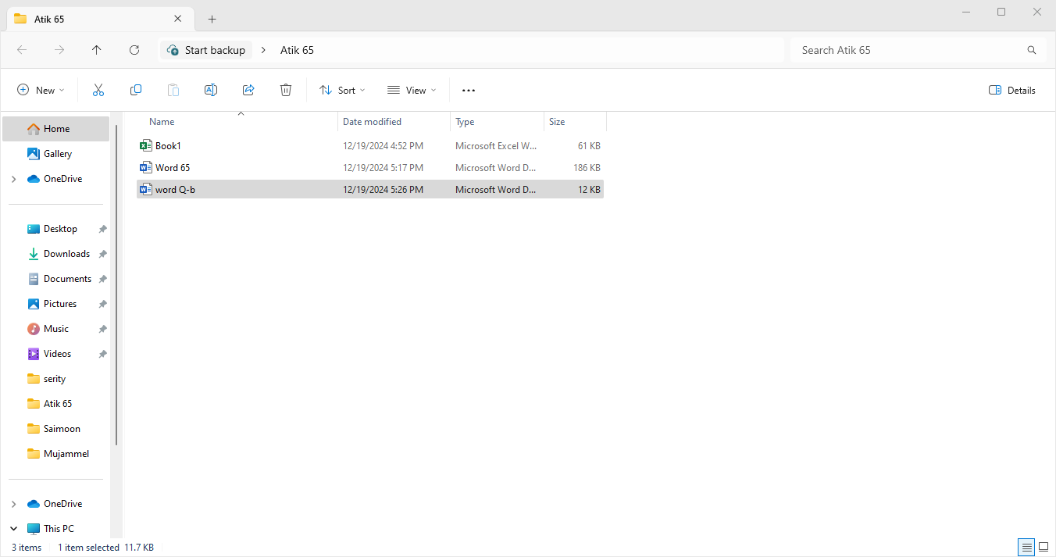

Group Shaps

**start**

**Process**

**End**